USER Interface Design
User Interface Design
The visual part of a computer application or operating system through which a client interacts with a computer or software. It determines how commands are given to the computer or the program and how data is displayed on the screen.

OR We can describe as following
User interface (UI) design is the process designers use to build interfaces in software or computerized devices, focusing on looks or style. Designers aim to create interfaces which users find easy to use and pleasurable. UI design refers to graphical user interfaces and other forms—e.g., voice-controlled interfaces.

Designing User Interfaces for Users
User interfaces are the access points where users interact with designs. They come in three formats:

- Graphical user interfaces (GUIs)—Users interact with visual representations on digital control panels. A computer’s desktop is a GUI.
- Voice-controlled interfaces (VUIs)—Users interact with these through their voices. Most smart assistants—e.g., Siri on iPhone and Alexa on Amazon devices—are VUIs.
- Gesture-based interfaces—Users engage with 3D design spaces through bodily motions: e.g., in virtual reality (VR) games.

To design UIs best, you should consider:
- Users judge designs quickly and care about usability and likeability.
  - They don’t care about your design, but about getting their tasks done easily and with minimum effort.
  - Your design should therefore be “invisible”: Users shouldn’t focus on it but on completing tasks: e.g., ordering pizza on Domino’s Zero Click app.
  - So, understand your users’ contexts and task flows (which you can find from, e.g., customer journey maps), to fine-tune the best, most intuitive UIs that deliver seamless experiences.
- UIs should also be enjoyable (or at least satisfying and frustration-free).
  - When your design predicts users’ needs, they can enjoy more personalized and immersive experiences. Delight them, and they’ll keep returning.
  - Where appropriate, elements of gamification can make your design more fun.
- UIs should communicate brand values and reinforce users’ trust.
  - Good design is emotional design. Users associate good feelings with brands that speak to them at all levels and keep the magic of pleasurable, seamless experiences alive.

UI Design Principles

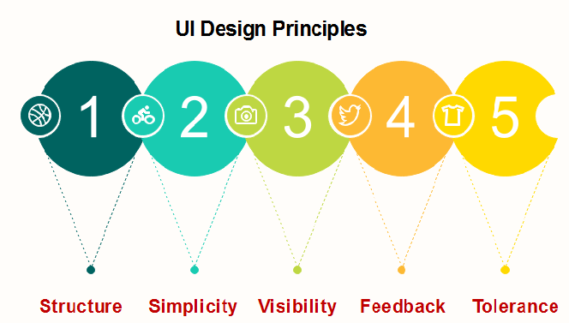
Structure: Design should organize the user interface purposefully, in the meaningful and usual based on precise, consistent models that are apparent and recognizable to users, putting related things together and separating unrelated things, differentiating dissimilar things and making similar things resemble one another. The structure principle is concerned with overall user interface architecture.
Simplicity: The design should make the simple, common task easy, communicating clearly and directly in the user's language, and providing good shortcuts that are meaningfully related to longer procedures.
Visibility: The design should make all required options and materials for a given function visible without distracting the user with extraneous or redundant data.
Feedback: The design should keep users informed of actions or interpretation, changes of state or condition, and bugs or exceptions that are relevant and of interest to the user through clear, concise, and unambiguous language familiar to users.
Tolerance: The design should be flexible and tolerant, decreasing the cost of errors and misuse by allowing undoing and redoing while also preventing bugs wherever possible by tolerating varied inputs and sequences and by interpreting all reasonable actions.

